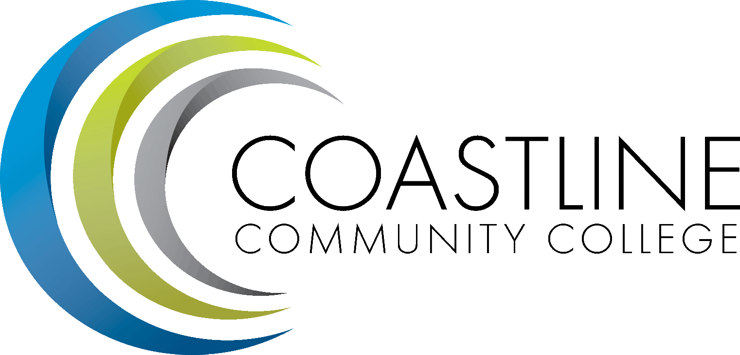

Education Bound United States
(CCC-EBUS)
3-Year College-level Course Plan
(for students beginning fall 2009)

The following curriculum plan is subject to change based on the readiness of the students. All courses offered will be college level courses though some may be remedial and/or meet prerequisites for transfer-level courses.

Total Possible College Credits = 41 (PENDING ENROLLMENT AND successful COMPLETION of ALL courses offered)

EBUS 3-YEAR PLAN
(fall 2009)

Year 1

Semester 2 (one college class): Possible Units (3.0)

Music 100 - MUSIC HISTORY AND APPRECIATION (3.0 units)

Study of major genres, forms, styles and historical periods in music since the Middle Ages. Emphasis on listening techniques, appreciation of classical and popular music and recognition of styles, composers and periods.
IGETC Category: Arts and Humanities

Year 2

Semester 1 (two college classes): Possible Units (8.0)
Geography 100 - Introduction to Geography (3.0 units)
Study of the physical and cultural features of various regions of the world. Examines the relationship between the physical environment and cultural, political and economic development. The tools of geographical analysis will be used to study current and potential world problems.
IGETC Category: Social and Behavioral Sciences

……………………………………………

Math 180 Calculus 1(5.0 units) Prerequisite: MATH C120—Trigonometry or MATH C170—Precalculus Mathematics (with a grade of “C” or better in either course) or achieve a qualifying score on
math Placement Test Elements of analytic geometry and an introduction to differential and integral calculus. Application is critical to this course. There is a prerequisite requirement for this course. Transfer Credit: CSU; UC credit limitations. See counselor.
(NOTE: Students will have to take a placement test to qualify for this course. Course offered depends on student placement scores.)
IGETC Category: Mathematical Concepts and Quantitative Reasoning

Year 2

Semester 2 (three college classes): Possible Units (9.0)

Humanities 110 - HUMANITIES THRU THE ARTS (3.0 units)
Survey of Western Civilization cultural achievement as expressed through music, literature, drama, film, painting, sculpture and architecture.
IGETC Category: Arts and Humanities

……………………………………………

ECONOMICS C185 3.0 Units Principles of Economics (MICRO) This course offers an introduction to the concepts and tools of economic analysis. The course studies price theory including supply and demand, marginal analysis, utility, cost and revenue concepts, perfect and imperfect competition, production and factor markets. Economic principles are applied to the analysis of such problems as industrial organization, the environment, public choice and the distribution of income. Transfer
Credit: CSU; UC
IGETC Category: Social and Behavioral Sciences

……………………………………………

Biology 100 - Introduction to Biology (3.0 units) Biology for non - science majors. A general study of the basic concepts of biology including the human body and the environment. Emphasis on the characteristics of plant and animal life, human body systems, health, genetics and the interaction of organisms in their environment.
IGETC Category: Physical and Biological Sciences

Year 2

SUMMER IN U.S. (two college classes): Possible Units (3.0)

HIST C170 - U.S. History to 1876 (3.0 units) of the United States from the beginnings
of exploration to the end of reconstruction after the Civil War. It covers the political, economic, diplomatic, social, and cultural aspects of American life during this time span. This course fulfills the UC and CSU requirements for the BA degree and is transferable to all state institutions of higher learning. Transfer Credit: CSU; UC
IGETC Category: American Institutions

…………………………

English 099 - Fundamentals of Composition (0.0 units)
Students write various types of paragraphs as well as review the basics of paragraph writing, grammar and mechanics.
(NOT APPLICABLE TO A.A. DEGREE) This course may be taken two times. Pass/No Pass only. Prerequisites: (CCC English Proficiency 20 or Coastline Undergraduate level English 097 Minimum Grade of C)
Year 3

Semester 1 (three college classes): Possible Units (9.0)

History 165 - World History from 1500 (3.0 units)
This course traces the economic, political, social, and cultural evolution of civilizations in Asia, the Near East, Europe, Africa, and the Americas from 1500 to the present. It covers the varied impact of industrialization and the creation of a global economy, the evolution and interaction of disparate political systems, and the development of diverse cultural, social, and ideological trends.
IGETC Category: Social and Behavioral Sciences

……………………………………………

SPCH C110 - Public Speaking (3.0 units)
Principles of public speaking, including planning, preparing, and delivering an effective oral presentation. Consideration of and practice in problem solving, information, persuasion, and communication techniques. Emphasis on developing self-confidence and skill in communicating to and with groups.
IGETC Category: English – Oral Communication

……………………………………………

English 100 - FRESHMAN COMPOSITION (3.0 units) The basic principles and process of written composition will be applied through examinations and assigned essays. The process of choosing and shaping a thesis and writing an extended, well-developed essay will be stressed. Practice in research and production of a research paper will be included.
(NOTE: Students will have to take a placement test to qualify for this course.)
IGETC Category: English Composition

Year 3

Semester 2 (Three college classes): Possible Units (11.0)

CHEMISTRY C180 4.0 Units General Chemistry A Advisory: Completion of CHEM C1130 or a recent high school chemistry course with a grade of C, and completion of MATH C030 or a recent high school course in intermediate algebra with a grade of C or appropriate placement on a math placement assessment. This course is the first semester of a two semester sequence (CHEM C180 and C185). A basic course in the principles of inorganic chemistry with special emphasis on chemical calculations and structure. Letter grade only. Transfer Credit: CSU; UC
IGETC Category: Physical Science

………………………………………………

CHEMISTRY C180L 1.0 Unit General Chemistry Lab A Prerequisite: Completion of CHEM C130 or a recent high school chemistry course with a grade of C, and completion of MATH C030 or a recent high school course in intermediate algebra with a grade of C or appropriate placement on a math placement assessment; Co-requisite: CHEM C180 (may be waived by demonstration of satisfactory completion CHEM C180 or equivalent.)
A basic laboratory course in the principles of inorganic chemistry and lab techniques with special emphasis on chemical calculations
IGETC Category: Physical Science

………………………………………………..

ECONOMICS C180 3.0 Units Principles of Economics (MACRO) This course examines and analyzes the economic problems of recession, unemployment and inflation. The focus of this investigation centers on business cycles, the measurement of output and income in the economy, the determination of the equilibrium level of national income, money creation and the banking system, monetary and fiscal policy options, international trade and finance and the effects of the public debt. The particular interactions of the domestic and international economies are studied throughout the course. Transfer Credit: CSU; UC
IGETC Category: Social and Behavioral Sciences

…………………………………………

ENGLISH C102 3.0 Units Critical Reasoning, Reading and Writing Prerequisite: ENGL C100—Freshman Composition This course is designed to develop critical thinking, reading and writing skills beyond the level achieved in English C100. This course focuses on critical thinking skills, close textual analysis and expository writing. Students apply critical thinking skills through readings derived from themes and works in various disciplines and cultures. Students also apply critical thinking skills in writing

expository argumentative essays. Transfer Credit: CSU; UC
IGETC Category: English Communication

